Dana Phelan

Ridgefield High School

700 North Salem Rd

Ridgefield, CT 06877

Grades 9 – 12

Visual Art (photography)

July 2015

Sense of Place and the Creative Process:

Looking at where you are and where you’re going

**Abstract**

This unit will guide students through a process of finding and attending to the sound of their “own drummers”. It is inspired by the seven iterations of the Different Drummer passage gathered by Jeffery Cramer. This collection of quotes is a fascinating example of how creative minds play with and work out ideas and develop them over time. Students will observe, reflect on, and interpret their local place through a series of discussions, journal entries, contour drawings and photographs. Along the way, they will consider passages from Thoreau and the visual images (and creative processes) of artists such as Hokusai, Albrecht Durer and Helena Emmans.

**Duration**

This is a unit of 8 lessons, spread over the course of 2 – 3 weeks. These high school photography students of mixed grades will be considering their home place and the creative process through different modes of process and communication. There are spaces between lessons that may be used for studio time and other projects. Before (and possibly interspersed within) this unit, these students will have learned about basic camera controls and Photoshop methods and techniques. The 2 – 3 week timeframe is meant to allow for the incubation/fermentation that is necessary to the creative process. During this time, students will develop an idea for place-based image making, and create a series of images that explore this place. We have a rotating block schedule with frequent schedule changes to accommodate assemblies etc. So, this unit may be arranged or rearranged to accommodate such changes.

**Objectives**

* Students will learn that local place can be a source rich in ideas and images
* Students will learn that the creative process is not a straight line; that it is often a meandering process of observation, exploration and experimentation.

**Outline**

**Lesson 1** (one 43 minute class)

Discussion of Development of “different drummer” passage

Small Group Discussion with handout

Introduce journaling as method that may be part of creative process

**Lesson 2** (one 43 minute class, students may finish during studio time the next day)

Journal Making

Teacher demo, student studio time

**Lesson 3** (one 43 minute class)

Looking at Images: Hokusai’s Views of Mount Fuji, Monet’s Haystacks, Mondrian’s trees, Helena Emmans’ images of the Isle of Skye

Small Group Discussion (why observe and interpret the same thing multiple times?)

Journaling: notes and sketches of meaningful places nearby one could document over time.

**Lesson 4** (one 30 minute class)

Image of Durer’s *Great Turf*,

Khan Academy video on Durer’s *Great Turf* (lavishing attention on something we don’t usually notice)

Journaling

Generate ideas for photo project - Same thing, nearby – local place, multiple times

**Lesson 5** (one 43 minute class)

Contour Drawing practice

It’s about slow looking, not about perfection

Looking at Ridgefield

In small groups, respond to historical photographs of places you know

HW: Begin photographing and drawing your subject

**Lesson 6** (one 43 minute class, students may finish during studio time the next day)

Bring photos of Home Place

Experiments in Black and White

**Lesson 7** (one 43 minute class)

Interpreting Home Place

Journaling

Gathering, sorting, mounting for Presentation

Preparation of work for Discussion

**Lesson 8** (one 90 minute long block class)

Group discussion and class sharing of process journals and final works

(critique)

**The Lessons**

**Lesson 1**

(one 43 minute class)

**Part One**

Discussion of Development of “different drummer” passage

Small Group Discussion with handout (20 minutes)

Learning Objective: Students will learn that well known artists and writers do not simply pour perfectly expressed ideas onto the page, but go through a long process of observing, thinking, experimenting and refining their ideas.

**Part Two**

Introduce journaling as method that may be part of creative process (approx. 20 minutes)

Share examples of artist journals

Learning Objective: Students will learn that visual artists (including photographers) often use process journals as a way of collecting, developing and reflecting on visual ideas.

HW: Bring any materials you’d like to use in making your journal

*Handout, Materials, Resource and Rubrics for this lesson follow this page*

Discussion Topic: The Creative Process

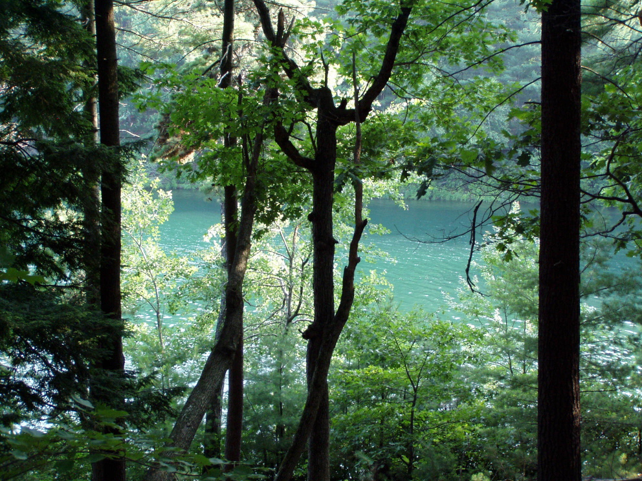

photo from waldenpondstatereservation.wordpress.com

Slowly read the following selections from the writings of Henry David Thoreau:

1840: *A man’s life should be a stately march to a sweet but unheard music, and when to his fellows, it shall seem irregular and inharmonious, he will only be stepping to a livelier measure, or his nicer ear hurry him into a thousand symphonies and concordant variations.*

1849: *Marching is when the pulse of the hero beats in unison with the pulse of Nature, and he steps to the measure of the universe; then there is true courage and invincible strength.*

1851: *For years, I marched as to a music in comparison with which the military music of the streets is noise and discord.*

1851: *Let a man step to the music which he hears, however measured.*

1851: *I am bothered to walk with those who wish to keep step with me. It is not necessary to keep step with your companion, as some endeavor to do.*

*Walden* (draft): *Let a man step to the music which he hears, however measured and far away*

*Walden* (1854): *If a man does not keep pace with his companions, perhaps it is because he hears a different drummer. Let him step to the music which he hears, however measured or far away.*

- passages compiled by Jeffrey S. Cramer, Curator of Collections, The Thoreau Institute at Walden Woods

Take a minute to think about what you’ve read.

Consider all these passages together.

Think about what is similar and different in the passages; what do you notice in terms of concept or idea?

What do you notice about the words Thoreau uses to express ideas?

What are these passages about?

What do you think or feel about what T. is saying?

How long was it between the first quote and the last?

What do these passages suggest about how Thoreau developed his ideas)?

What kinds of connections might there be to the process of creating in the visual arts?

Visual Arts Discussion/Critique Participation Rubric

Name _______________________ Class Section ______

Topic __________________________________________

|  |  |  |  |
| --- | --- | --- | --- |
| A | B | C | D |
| Thoughtfully engages in discussions by taking time to look, asking questions, sharing thoughts, and truly listening and responding to others. Respect for others and the learning process is important to this student. | Participates in discussion/critique by looking, asking questions and making comments. | Student would learn more by engaging more fully in the critique process. | Student would learn more by engaging in the critique process. |

**Lesson 2**

(one 43 minute class; students may finish during studio time the next day)

**Journal Making**

Teacher demo (approx 10 minutes)

1. orientation to tools, materials & resources
2. cutting, folding paper
3. piercing paper
4. covers and other options
5. sewing/binding

student studio time and clean up time (approx 33 minutes)

**Learning Objectives:**

Students will learn that there is a choice of materials, tools and methods available to craft a hand made book.

Students will learn that taking time to create a journal with one’s hands can make the experience of journaling more meaningful right from the start.

*Handout, Materials, Resource and Rubrics for this lesson follow this page*

**Materials & Resources for Journaling Intro**

Bookmaking supplies: various papers, board, glue & glue sticks, paintbrushes, book binding tape, hole punchers, paper drill, awls, dull tipped needles, threads, twines and cords, scissors, paper cutter.

Student Journals from prior years

[Shereen LaPlantz](http://www.amazon.com/Shereen-LaPlantz/e/B000APP0DM/ref=dp_byline_cont_book_1) Cover To Cover: Creative Techniques For Making Beautiful Books, Journals & Albums

Dan Eldon The Journey is the Destination

Name _________________________________ Section__________

Hand Made Journal Construction: Rubric

|  |  |  |  |  |
| --- | --- | --- | --- | --- |
|  | A+/A | B+/B | C+/C | D/F |
| Work process/Craft | Student uses time and resources to the fullest to make a carefully crafted journal. Student takes initiative in finding information and experimenting with materials. | Student uses time and resources well to make a journal. Student is willing to find information and experiment with materials. | Student makes some effort, but needs to spend more thought and energy on the process of making. | Student invests little energy or thought in making journal |
| Consideration of Use and Purpose | Journal is well made and substantial and will be easy to use in the classroom and outside | Journal is reasonably well made and can be used | Journal may not stand up to much use. | Journal is not well made enough to be used. |

Grade for Journal Construction: ________________**Lesson 3**

(one 43 minute class)

Artists who have revisited the same scenes, places or subjects repeatedly, over time

**Looking at Images:**

* Hokusai’s *36 Views of Mount Fuji*
* Monet’s *Haystacks* series
* Helena Emmans’ images of the Isle of Skye

**Small Group Discussion** : Why observe and interpret the same thing multiple times?

(approx 25 – 30 minutes)

Students use the resources list (following page) to frame a discussion around the question above.

**Journaling** (last 10 – 15 minutes)

Why revisit the same place?

Are there practical reasons to do this?

Artistic reasons?

How can you see something new in a place that you think is familiar?

How could this be important?

What kinds of ideas might you use from the images you saw that could be adapted to photography in Ridgefield, in 2015?

You’ll be observing and photographing a place near your home multiple times over the next few weeks. Please make notes and sketches in your journal to brainstorm ideas for this assignment.

HW: Look around for a place near your home, and spend 5 quiet minutes there, just looking. Make a note or sketch of something you had not noticed before.

**Materials & Resources for Discussion on Artists revisiting subjects over time**

*Some questions to begin your conversation:*

* Look at the images made in the same place, over time, by different artists. what do you see?
* Why do/did these artists keep going back to the same places or subjects?
* What remains the same and what changes over time?

**Hokusai**:

Introductory Information about Hokusai exhibit at Boston MFA

<http://www.mfa.org/news/hokusai>

*“In 1830, at the age of 70, Hokusai began the project that would eventually make him famous around the world: the woodblock print series Thirty-six Views of Mount Fuji (about 1830–31)”*

A pdf that has large images of Hokusai’s Views of Mount Fuji, organized by the Boston MFA

[*http://educators.mfa.org/sites/educators.mfa.dev/files/36ViewsofFuji.pdf*](http://educators.mfa.org/sites/educators.mfa.dev/files/36ViewsofFuji.pdf)

**Monet:**

Five of the Haystack paintings by Claude Monet can be seen together on this blog:

The Untended Garden: A Celebration of Art and Nature by John Lechner

[*http://untendedgarden.com/category/painting/?sa=X&ved=0CDAQ9QEwDWoVChMI8dDCr-XxxgIVRhU-Ch3fvgXN*](http://untendedgarden.com/category/painting/?sa=X&ved=0CDAQ9QEwDWoVChMI8dDCr-XxxgIVRhU-Ch3fvgXN)

**Helena Emmans:**

Her website, showing her art in many different media

Pay particular attention to her photographs, paintings, and hand dyed thread pieces and how these interpret the landscape where she lives.

[*http://helenaemmansartist.com*](http://helenaemmansartist.com)

**Other Resources**

Computers with a good-sized monitors so that all the group members can see.

Internet access

**Assessment**

Use the Discussion Participation Rubric that appears in Lesson 1.**Lesson 4**

(one 30 minute class ie: a day with a special schedule such as an assembly day)

Paying attention to what is right here, under our feet

Image of Durer’s *Great Turf*,

Watch together, as a whole class

Khan Academy video on Durer’s *Great Turf* (lavishing attention on something we don’t usually notice)

<https://www.khanacademy.org/humanities/renaissance-reformation/northern/durer/v/albrecht-d-rer-the-large-piece-of-turf-1503>

Journaling: Notes and sketches

* What did you think of Durer’s watercolor?
* What did you think about his choice of subject?
* What was interesting about the dialogue you heard?
* How might this connect to our project interpreting Ridgefield?
* Generate ideas for photo project - Same thing, nearby – local place, multiple times.

Discuss and establish criteria for project, methods, processes and due dates.

HW: Spend time in the place you’ve selected. Observe quietly. Take photographs.

**Lesson 5**

(one 43 minute class)

**Part One:** (15 minutes)

Slow Looking Exercise: Contour Drawing

Introduction and Demo: It’s about looking with care and attention, not making perfect drawings

Observe a living thing, in the school courtyard

Create contour drawings:

1. One for one minute
2. One for 5 minutes

Tape, clip or glue these into journals if they have been made on separate pieces of paper. If they are very large drawings, they may be photographed, resized, printed and inserted into journals.

**Part Two:** (approx 25 minutes)

Looking at Ridgefield

small group – respond to historical photographs of places you know (handout follows this page)

HW: Begin photographing and drawing your subject at your home place. Sketch and make notes in your journal about the experience of each method.

**Materials & Resources**

Looking at Historical Photographs of Ridgefield

Sense of Place

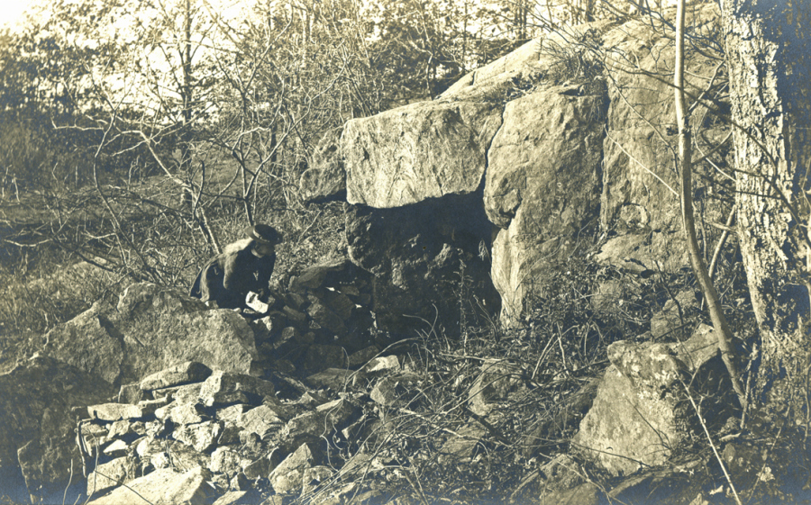

Sarah Bishop’s Cave. Photograph by Marie Kendall, ca. 1900. The Connecticut Historical Society

Spend some time with your small group searching online for information on the photograph above, by Connecticut photographer Marie Hartig Kendall.

What did you discover?

Look at the historical photographs on the blog below. (Jack Sanders writes for the Ridgefield Press) Don’t stop at the first photograph you open. Keep going…

<http://jackfsanders.tripod.com/pcindex.htm>

Share what you see with your group.

* What do you recognize?
* What is the same/different today?
* What surprises you?
* How do these images alter your perception of Ridgefield?
* Create 3 open-ended questions raised by these images and write them below:

**Materials for Contour Drawing**

Student Journals or drawing paper

Soft Drawing tools such as ebony pencils, Conte crayons or black markers

Drawing boards, clipboards or hardcover books to lean on

Tape, paperclips or glue

**Lesson 6**

(One 43 minute class)

Experiments in Black & White

On due date established by class and teacher:

Students bring digital images of their Place and download these photos (or access them on Google Drive)

Students experiment with black and white techniques in Photoshop (handout on following page)

Some experiments in black & white

Here are a few techniques to get you started. Any one of these can be taken in any number of directions. Please experiment freely before you decide you are done! Keep notes on what you did in your journal. Include questions and reflections too. Leave space to include the images later. (See last bullet point below)

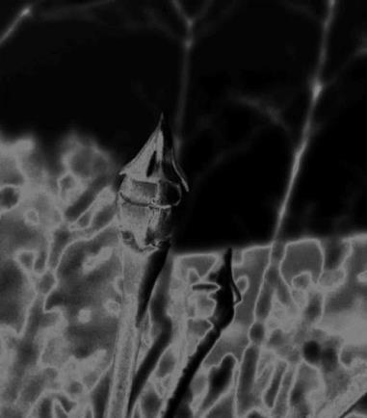

Photoshop solarized image by Ms. P

Open a few photos in Photoshop and experiment with some black and white techniques. Try these:

* Image Adjustments, Hue & Saturation. Try the saturation slider all the way or part of the way.
* Image adjustments, Black & White (notice the sliders in the pop up box. Try them, what do they do?)
* Image adjustments, Invert
* Any of the above within a selected area
* Filter, Stylize, Solarize (this mimics a darkroom technique where you expose a print to light while it has developer on it) What effects does it have?
* Transform a photo into black and white, then use the History Brush to return parts of it to color. 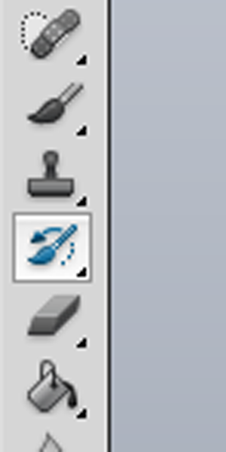 The History Brush and the Art History Brush are not the same thing. Experiment to figure out how they work. Note that the history brush only works if you have not changed the size of the image since you last opened it, which moves the pixels around from where they were when the document was last saved. Zoom in as you work!
* Try making a photo B&W then putting a Photo Filter over it. These are under Image Adjustments. You can experiment with setting different colors & intensities for your filter. You can choose filter colors from the palette or from another photo that you have open in Photoshop.
* Save each experiment under a new name!

**In Your Journals:**

* Print your 3 most interesting or satisfying experiments. Print them small (4 or 5 inches by 4 or 5 inches) Make sure to include brief explanation of what you did.

**Materials & Resources**

Student cameras

Class Computers (1 per student)

Internet access

Adobe Photoshop

Laser printer

Artist tape

Color pencils/markets

**Assessment**

Students may be assessed for their work process using the rubric on the following page

Students will be assessed for their journal and final works at the end of the unit.

Visual Arts Class Participation Rubric

Name _______________________ Date__________ Class Section ______

|  |  |  |  |  |
| --- | --- | --- | --- | --- |
|  | Excellent 20 | Very Good 17/18 | Moderate 14/15 | Needs Work 12 |
| Initiative | Student often initiates questions/suggests ideas, ways of working, and new things to try. | Student occasionally initiates/suggests ideas, questions, ways of working, and new things to try. | Student rarely initiates/suggests ideas, questions, ways of working, and new things to try. | Student seems disengaged & needs to take a more active approach to learning. |
| Curiosity | Displays open mindedness, curiosity, wants to understand, try new things, experiment, ask questions & learn | Usually displays open mindedness and curiosity, | Sometimes displays open mindedness and/or curiosity, | Student would benefit by opening his or her mind to new things and finding ways to become involved in learning. |
| Respecting & Helping Others | Treats others with respect, never causes classroom disturbances, and offers ideas and suggestions to others that deepen our understanding. | Treats others with respect, rarely causes classroom disturbances, sometimes offers ideas or asks questions of others. | In most cases treats others with respect, rarely causes classroom disturbances, may occasionally forget to clean up the studio | Needs to treat others with respect consistently: often disturbs or distracts others, does not engage in an exchange of ideas, often does not clean up after working. |
| Work Ethic & Perseverance | Uses obstacles as learning opportunities, thinks about how to adapt activities to make them more interesting, goes beyond basic requirements. | Usually overcomes obstacles, meets challenges, and fulfills requirements. | Occasionally overcomes obstacles, attempts to meet challenges, usually meets basic requirements. | Allows obstacles to interfere  with learning process and uses  them as an excuse to not fulfill requirements. If he or she does not know how to proceed, disengages and does not work. |
| Participation in Critiques | Thoughtfully engages in critical discussions of one’s own work and that of others by asking questions, sharing thoughts, and making connections. | Participates in critiques by asking questions and making comments. | On occasion, the student participates in critiques by asking questions or making comments. | Student would learn more by engaging in the critique process. |

Total Grade _______________________

*a note from your teacher: in an art class a student may speak orally, with his or her voice (the one that comes out of your mouth), but bear in mind that an artist also speaks in images, with his or her artistic voice. This is speaking in a visual language, and this is very important. This is what we do*

**Lesson 7**

(one 43 minute class)

Interpreting Home Place – **Small Group Sharing & Discussion** (10 minutes)

How can you present your images and process journals to communicate a sense of the place you’ve chosen?

Gathering, sorting, printing, mounting and **preparation for unit presentation and critique**

(33 minutes during this class, and studio time during following classes if needed)

Review project rubric with students (included here after Lesson 8)

Establish date when students will present their process journals and final images (they may benefit from a few more days of studio time)

**Lesson 8**

(Long Block class – 90 minutes)

Group discussion and class sharing of process journals and final works

(critique)

* Students lay out their works in a central area, such as a large worktable. Students who do not want their work to be handled should affix a sticky note indicating that. (5 minutes)
* Students circulate, look at the work, and carefully look through the journal pages.
* Each student makes notes about his/her own work and that of 3 – 4 other students that address the following (and any other) questions:

1. How do the final images and process journals communicate a sense of place?
2. What can we glean about the artists’ processes from looking at the journals?
3. What do we want to know more about?
4. How have our ideas about the creative process changed?
5. How have our ideas about Ridgefield changed?

(Time frame for bullets 2 & 3 is approx. 15 minutes)

* Full class discussion about entire project, process journals and final pieces.
* Generate ideas for future

**Assessment**

Student participation in the class discussion/critique will be a self-assessment using the Class Participation Rubric included in Lesson 6

Students final images and process journals will be assessed using the “Visual Arts Project Rubric: Sense of Place and Creative Process” that follows this lesson.

Visual Arts Project Rubric: Sense of Place and Creative Process

Name _______________________ Date__________ Class Section ______

|  |  |  |  |  |
| --- | --- | --- | --- | --- |
|  | Excellent (25) | Very Good (20 – 24) | Moderate (16 – 19) | Needs Work (15 max.) |
| Sense of Place | Student journal, images and participation communicate a meaningful, connection to and strong interest in local place | Student journal, images and participation communicate a connection to and interest in local place | Student share some evidence of interest in local place | Student seems disengaged & does not show evidence of an interest in local place |
| Curiosity | Displays open mindedness, curiosity, wants to learn, understand, try new things, experiment with different media and interpret local place in many ways. | Usually displays open mindedness and curiosity, some experimentation evident. Student may find that more openness to the creative process will result in much stronger artwork. | Sometimes displays open mindedness and/or curiosity, student is encouraged to experiment more and become more open to the creative process. | Student would benefit by opening his or her mind to new things and finding ways to experiment and become involved in creative process. |
| Composition and Craft of Journal and Images | Visual artwork shows care and willingness to spend time, thought and energy | Visual artwork shows care, with only a few areas that have been left unconsidered. | Visual artwork shows some care, but there are several areas that have been left unconsidered. | Visual artwork needs more attention and concern |
| Work Ethic & Perseverance | Uses obstacles as learning opportunities, thinks about how to adapt activities to make them more interesting, goes beyond basic requirements. | Usually overcomes obstacles, meets challenges, and fulfills requirements. | Occasionally overcomes obstacles, attempts to meet challenges, usually meets basic requirements. | Allows obstacles to interfere  with learning process and uses  them as an excuse to not fulfill requirements. If he or she does not know how to proceed, disengages and does not work. |

Total Grade _______________________

Materials, Tools, Worksheets and Grading System are included with each lesson

**Bibliography**

Jeffrey S. Cramer Tracing the “different drummer” passage handout, with the following citations:

1. *I to Myself: An Annotated Selection from the Journal of Henry D. Thoreau,* edited by Jeffrey S. Cramer (Yale University Press, 2007)
2. *A Week on the Concord and Merrimack Rivers* (Houghton Mifflin, 1906)
3. *The Journal of Henry D. Thoreau*, edited by Bradford Torrey and Francis H. Allen (Houghton Mifflin, 1906) Volume II
4. *The Development of Walden: A Genetic Text* by Ronald Earl Clapper, Thesis (PhD. – University of California, Los Angeles 1967) draft version
5. *Walden: A Fully Annotated Edition, ,* edited by Jeffrey S. Cramer (Yale University Press, 2004)

Dan Eldon *The Journey is the Destination*, Chronicle Books; 1st edition (August 1, 1997)

[Shereen LaPlantz](http://www.amazon.com/Shereen-LaPlantz/e/B000APP0DM/ref=dp_byline_cont_book_1) *Cover To Cover: Creative Techniques For Making Beautiful Books, Journals & Albums* Lark Crafts; 1st Pbk. Ed edition (June 30, 1998)

**Link to State Standards:**

**Connecticut State Standards 1** **– 6 for the Visual Arts** (mapping the standards from Kindergarten through High School)

<http://www.sde.ct.gov/sde/cwp/view.asp?a=2618&q=320818>

**Other Links**

Helena Emmans’ artist website:

[*http://helenaemmansartist.com*](http://helenaemmansartist.com)

Marie H. Kendall

*Sarah Bishop’s Cave.* Photograph, ca. 1900. The Connecticut Historical Society

<http://chs.org/2013/11/sarah-bishops-cave/>

Khan Academy Video about Durer’s *The Large Turf:*

<https://www.khanacademy.org/humanities/renaissance-reformation/northern/durer/v/albrecht-d-rer-the-large-piece-of-turf-1503>

Lechner, John *The Untended Garden*, blog

With images of Monet’s *Haystacks:*

[*http://untendedgarden.com/category/painting/?sa=X&ved=0CDAQ9QEwDWoVChMI8dDCr-XxxgIVRhU-Ch3fvgXN*](http://untendedgarden.com/category/painting/?sa=X&ved=0CDAQ9QEwDWoVChMI8dDCr-XxxgIVRhU-Ch3fvgXN)

Roberts, Jennifer L. *The Power of Patience: Teaching students the value of deceleration and immersive attention* in *Harvard Magazine* November – December 2013:

<http://harvardmagazine.com/2013/11/the-power-of-patience>

Sanders, Jack. Blog with historical photographs of Ridgefield, CT:

<http://jackfsanders.tripod.com/pcindex.htm>

Teicher, Jordan G. *A Glimpse Into Professional Photographers’ Sketchbooks* in Slate online 2/1/2015. Review of *Photographers' Sketchbooks*by [Stephen McLaren](http://thamesandhudsonusa.com/contributors/stephen-mclaren), [Bryan Formhals](http://thamesandhudsonusa.com/contributors/bryan-formhals). Thames & Hudson 2014:

<http://www.slate.com/blogs/behold/2015/02/01/the_book_photographers_sketchbooks_shows_the_creative_process_of_photographers.html>

Tishman, Shari. Out of Eden Learn Blog: Slow Looking and Complexity July 2014

<http://walktolearn.outofedenwalk.com/2014/07/21/slow-looking-and-complexity/>

Sketchbook Ideas from Student Art Guide online:

<http://www.studentartguide.com/articles/photography-sketchbook-ideas>

Information on Hokusai from the Boston MFA:

<http://www.mfa.org/news/hokusai>

and:

[*http://educators.mfa.org/sites/educators.mfa.dev/files/36ViewsofFuji.pdf*](http://educators.mfa.org/sites/educators.mfa.dev/files/36ViewsofFuji.pdf)