Colette Morton

Gateway STEM
5101 McRee Avenue
St. Louis, MO 63112

Grade 10
English II
8/2/2015

“Nature in our City: Engaging with an Urban Environment”

The St. Louis metro area is very large and exploring the woods can be nearly impossible for poor, urban teenagers. The purpose of this unit is to inspire students to interact with nature in new ways, all while developing a sense of place. First, we will examine writers who have inspired many to step out into nature. The reading list will include selections from Jon Krakauer’s Into the Wild, Aron Ralston’s Between a Rock and Hard Place, The Wilderness World of John Muir edited by Edwin Way Teale, Henry David Thoreau’s Walden, Bill Bryson’s A Walk in the Woods, and John Steinbeck’s Travels with Charley. Throughout this unit, the students will journal “in the field,” using classical field notes in their urban environment. Finally, we will Skype Yosemite National Park, attempting to get Shelton Johnson to speak with our students (https://en.wikipedia.org/wiki/Shelton_Johnson). Finally, we will invite the last mayor of Times Beach, Marilyn Leistner, to speak with our students about the ecological disaster that occurred only a few decades and miles away.

This unit will satisfy our state standards which focuses mainly on nonfiction. Passages selected will mirror the type found on the Missouri state tests.

Duration: This unit will take a quarter to complete (five weeks).

Objectives: Students will be able to
- analyze how an author’s choices concerning how to structure a text, order events within it (e.g., parallel plots), and manipulate time (e.g., pacing) (Into the Wild)
- Determine a central idea of a text and analyze its development over the course of the text, including how it emerges and is shaped and refined by specific details; provide an objective summary of the text (All selections).
- Determine an author’s point of view or purpose in a text and analyze how an author uses rhetoric to advance that point of view or purpose (All selections).
- Identify and analyze figurative language in context.
- Evaluate and analyze text features, including charts, maps, etc.
- Develop and strengthen writing as needed by planning, revising, editing, rewriting, or trying a new approach, focusing on addressing what is most significant for a specific purpose and audience (All selections).
- Conduct short as well as more sustained research projects to answer a question(including a self-generated question) or solve a problem; narrow or broaden the inquiry when appropriate; synthesize multiple sources on the subject, demonstrating understanding of the subject under investigation (All selections).

Outline:
Lesson One:
Day 1:
Learn about field journals, seeing examples.
Explore our neighborhood and reflect in field journals.
Hike “Gateway Mountain” where they will explore the plants and animals of a small pond and a tiny trail.

Lesson Two:
Day 2-5:
Start with Ordeal by Cheque and work on inferencing.
Read Jon Krakauer’s Into the Wild
View a Prezi to learn about a little more about Chris McCandless.
Reflect on the quotes and ideas that inspired McCandless.
Keep dialectical journals.
Relate music/poetry to Into the Wild.
Socratic Seminar using both the book and the film.

Lesson Three:
Day 6-7:
View a Prezi to learn a little more about Aaron Ralston.
Watch ten minutes of 127 Hours.
Read Aaron Ralston’s Between a Rock and Hard Place.
Evaluate text features, specifically maps.
Biology lecture on how to Ralston amputated his arm.

Lesson Four:
Day 8-9:
View a Prezi on Yosemite National Park
Watch a segment of Ken Burn’s documentary on the National Parks, specifically the John Muir in Yosemite and Alaska.
Relate this segment to McCandless.
Read The Wilderness World of John Muir edited by Edwin Way Teale
Skype with Shelton Johnson at Yosemite National Park

Lesson Five:
Day 10-11:
View Prezi on Walden Pond.
Read Henry David Thoreau’s Walden.
Explore the physicality of Thoreau’s cabin.
Annotate text through Jigsaw activity.
Begin expository writing assignment.

Lesson Six:
Day 12:
View Prezi on the Appalachian Mountains.
Read Bill Bryson’s A Walk in the Woods
Socratic Seminar.
Continue expository writing assignment.

Lesson Seven:
Day 13:
Read John Steinbeck’s Travels with Charley.
Short socratic seminar on how we treat animals.
Discuss our views on Compare/contrast all the writers.
Assign the expository essay on nature.

Lesson Details:
Lesson One:
Day 1:
Essential Question: When you hear the word “nature,” what do you think? How does society view nature? What are your views of nature? Are these positive or negative? Does this change if you live in the country? Suburbs? The city?

Do Now: Students will watch a prezi presentation on field notes.

Activity: Students will get their own notebooks to keep and take notes.
We will walk around the neighborhood to get a sense of place. Gateway is located in the city, with a highway a mere two blocks away. We will attempt to focus on the natural, first on the sounds (birds), then sights (trees, grass, etc.), smells (this may not be pleasant because we are near a cheese and airplane parts factory), touch and taste (though there is nothing to really eat along the way).
We will do the same along Gateway mountain (a former, 1920s landfill next to the school).
Finally, we will return to classroom and write a reflection. What were the similarities or differences between these two areas? Could you hear the birds over 44 highway? Were you able to smell anything besides cheese? How far apart were these two environments? What are your overall impressions of this experience? Their finished story will be considered classwork that turns into homework.

Lesson Two:
Day 2:
Into the Wild

Essential Question: How does an author decide to arrange his/her information? Why would a writer choose chronological over least to most important?

Do Now: Students will each have a copy of Ordeal by Cheque. They will read it silently.

Activity: For fifteen minutes, students will work in small groups to determine the story surrounding the checks. They will outline these events. Then students will return to their desks and begin writing their own story based on the checks. I will give them fifteen minutes to write on their own and then they will be expected to finish on their own. Their finished story will be considered classwork that turns into homework.
Begin reading chapter 12 of Into the Wild as a group, focusing on epigraphs, structure of novel, inductive reason, and various literary devices.

Homework: Do a dialectical journal for chapters 1-5.

Day 3:
Into the Wild
Essential Question: What does it mean to live deliberately? What answers might wilderness hold that the city does not?

Do Now: Listen and respond to Society and Rise by Eddie Vedder.

Activity:
Watch the following Prezi:
https://prezi.com/gzwyvh2wliyx/chris-mccandless/
Students will take one passage from their dialectical journal and expand further on it.
Share journal entries and discuss.
Socratic questions to guide the conversation:
- Chris McCandless steps off the road into the Alaskan wilderness carrying only what will fit in his backpack. In doing so, he joined a small but committed group of individuals who in some way reject the ideals and lifestyle of modern America (or their culture). Who are these individuals? What are they looking for? Why are they dissatisfied with their lives or the way others live?
- Think about other “rebels” you have known. Dr. King, Malcolm X, Malala, Crazy Horse, Gandhi, Eminem, Public Enemy, NWA, the unibomber, the people of the Waco massacre, Timothy McVeigh. Make a list. What are their similarities and differences? Is being a “rebel” always a good thing? Now let’s relate these people to Chris McCandless. Did they have the same goals? Did they accomplish their goals? Do you always need to accomplish your goals if you are a rebel?

Day 4:
Watch Into the Wild
Essential Question: Does our response to any situation shape our reality rather than the situation itself?

Do Now : Carefully think over the choices Chris McCandless made throughout his life. What strikes you most about these decisions? Does it align with any choices you have made? Could his life inspire you or do see this as a cautionary tale? Write freely, as if you were simply free-associating with the things that McCandless has said. Do not concern yourself with evaluating your thoughts; just express them.

Activity:
During the film, keep a dialectical journal and consider the following five statements (classwork):
(1) risky behavior can have fatal consequences
(2) parents need to be careful in raising their children
(3) there are times when children need to forgive their parents
(4) happiness and beauty must be shared to be fully enjoyed
(5) relationships with people are an essential part of life.

Day 5:
Watch Into the Wild
Essential Question: What does it mean to be an individual? What are the consequences of the following your own path?

Do Now: Respond to the following Thoreau quote: "If a man does not keep pace with his companions, perhaps it is because he hears a different drummer. Let him step to the music which he hears, however measured or far away. It is not important that he should mature as soon as an apple tree or an Oak. Shall he turn his spring into summer?"

Activity/Homework: After the film, consider TWO of the following questions in a five paragraph essay (assessment):
- Some contend that McCandless was arrogant or just plain stupid by going into the Alaskan wilderness only to die in an abandoned bus. Do you agree or disagree? State your reasons and back them up with direct reference to the film or with logical reasoning.
- Krakauer asks in his last chapter whether McCandless walked away from misery when he walked Into the Wild or whether he walked into happiness? How would you answer this question? Cite evidence to support your answer.
- Irony can be found in the fact that once McCandless seemed to have discovered the value of family, he could not return to society because the stream he had crossed earlier at a place marked by his hat is no longer passable. He must wait out the rush of water from the spring run-off. He dies before he can make it back. Look at the stream as a metaphor. Compare the stream to something in McCandless' life.
- It seems that McCandless finally discovered the value of relationships and would have returned to become a part of society had he survived. What is your opinion of this idea? Your opinions must be backed up with support from the film and logical argument.
- Do you agree with the statement that McCandless' family situation was a minor influence in McCandless' decision to go into the wild? Use evidence to justify your answer.

Lesson Three:
Between a Rock and a Hard Place
Day 6:
Essential Questions: Why does an author choose his/her organizational patterns? What causes a person to be a risk taker? How difficult is it to decide to take drastic measures in certain situations?

Do Now: Watch the first ten minutes of 127 Hours. Describe the terrain/Canyonlands. Be sure to include color, texture, lighting. How warm do you think it is? How much food and water would take with you on a weekend excursion?

Activities: Begin reading an excerpt of Between a Rock and a Hard Place.
http://www.outsideonline.com/1927626/trapped
Focus on literary devices such as hyperbole, metaphors, similes, litotes, etc. Highlight them. Jot down a few notes next to each highlighted portion. Consider how the figurative language works in the piece? Does it help the reader better understand the passage or does it hinder through distraction? Do the allusions/metaphors/etc. seem to be for a younger or older audience? Explain.

Come together as a group and explain your findings.

Day 7:
Essential Questions: What does it mean to live deliberately? What are the risks people take when they go into nature? Would an older person take these kinds of risks?

Do Now: Hindsight is 20/20. Both McCandless and Ralston were experienced with the wilderness, camping and hiking at very young ages. What could these young men do to prevent their death/accident? Do you think the probability of disaster increases with the number of risks taken? What activities do teenagers engage in that are simply not safe? Which seem safe, but only to a certain degree?

Activities:
Have students evaluate a map of the four corners. I will place this on the Smart Board and we will evaluate this first in groups of three and then as an entire class.
- What elements are missing from this map?
- Ralston uses a map in his book. Would this map suffice? Explain.
- Given that McCandless did not have a map, did it help Ralston to carry one?
- Title map.
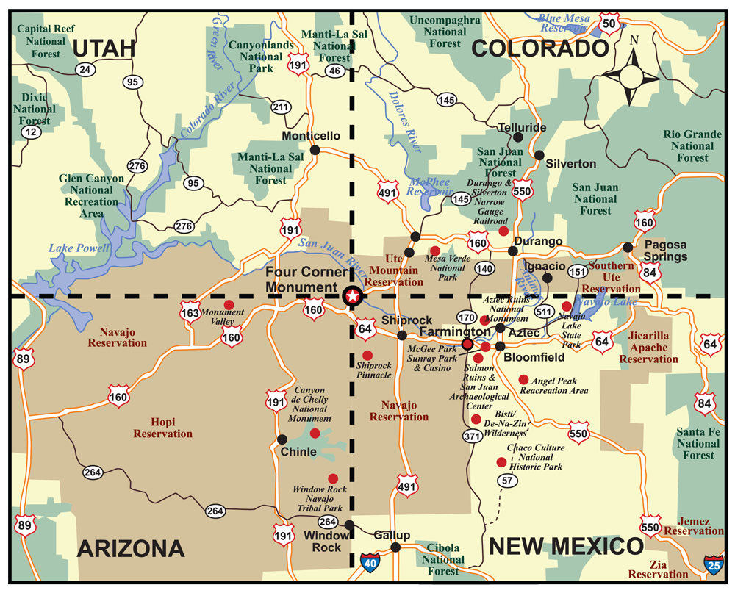
Continue reading an excerpt of Between a Rock and a Hard Place.
http://www.outsideonline.com/1927626/trapped

The AP Biology teacher will come into the classroom as my guest speaker to cut off an arm of a full-sized, male skeleton. Our school has classroom sets of model arms that have been cut at the exact spot Ralston amputated his. They are used to teach how to suture. At the end, they will journal on the experience, putting themselves in Ralston’s place (classwork to homework).

In a sense, this will create a sense of place. The students are unable to go to Canyonlands, but they can “experience” the logistics of his amputation.

Lesson Four:
The Wilderness World of John Muir
Day 8:
Essential Questions: What are the reasons people may take to the woods? What does it mean to really give yourself to nature? To anything really? What does it mean to be a hypocrite?

Do Now: Respond to the following John Muir quote. Relate it to both McCandless and Ralston if you can.
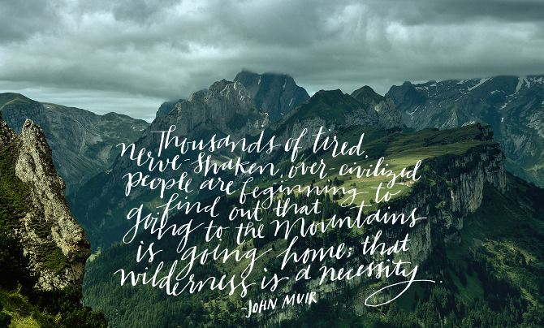

Activities:
Prezi on John Muir.
https://prezi.com/d2gpskjciaac/john-muir
Read the “Emerson at Yosemite” from John Muir’s book The Wilderness World of John Muir.
Explore the relationship between Muir and Emerson. Emerson is still a hero among many naturalists. Imagine Muir’s surprise when he Emerson barely walks through Yosemite’s Mariposa Grove then refuses to camp with him. In the end, Muir says he is happy with his trees (“the trees had not gone to Boston”), but we left feeling, well, sad for him. Imagine meeting McCandless or Ralston or Muir. Do you believe them to be genuine? Do you think they would live up to your expectations?

Students will keep a guided dialectical journal for this short passage.

Day 9:
Essential Questions: Besides living in the woods, how do people connect with nature? What are some alternatives to the lives chosen by McCandless? Muir? Ralston?

Do Now: Write down three questions you would like to ask a naturalist/park ranger.

Activities:
Watch the National Parks: America’s Best Ideas disc 1, specifically the part about Muir in Alaska. Parallel Muir’s feelings about Alaska with McCandless’. Muir slept on glaciers to cure him from a persistent cough. Go back to the Muir essay about Emerson. Emerson’s handlers stated that Waldo was too old to be outdoors and yet Muir lived almost his entire life outside. Is this a myth that still persists? Does the cold in of itself make you ill?

Bring Yosemite and Mariposa Grove to the classroom through Skype. Very, very few of them have been out of state. They should think about what drove Shelton Johnson to the wilderness. He was inspired by the Buffalo Soldiers (such as Charles Young). Tell his story to inspire the students.
Skype Yosemite National Park.
Have students prepare their questions in advance.

Lesson Five
Walden
Day ten:
Essential Questions: How much of yourself do you sacrifice when you choose to live in “society”? Try to imagine what McCandless, Ralston, and Muir would think of the world today. Would this change? Who determines what is right or wrong? You? Society? Your parents?

Do Now: What is your favorite season and why? What memories have occurred during that season for you? Does the season affect the memory?

Activities:
Show Prezi:
https://prezi.com/rnimlztikogv/henry-david-thoreau/

The actual size of the cabin will be taped off on the floor. Students will have an opportunity to stand in the space. They will then return to their seats and journal their thoughts.

Thoreau spent much of his time reflecting and writing about his days. He did not wait for them to become distant memories. The smells, sounds, pictures, tastes, and touch of nature was with him as he wrote, but he was also a Harvard educated man who incorporated his own readings in his writing.

Get into groups of four. Take the passage and look for the annotation numbers. Using the internet, try to figure out what Thoreau was alluding to. Write them down in order (classwork). Come back as a group and discuss.

Day eleven:
Essential Questions: How does nature and our environment affect our state of mind? Does being out in nature make us happy/unhappy? Has our idea of nature changed over time?

Do Now: Continue thinking about your favorite season question from yesterday. Take one of your memories and really try to remember the details. Who were the characters involved? What were the “plot points” of your memory? Try to write down as much of the story as you can remember.

Activities: We continue reading Walden. Today, in the same groups, students will annotate their own texts. Just like with Ralston’s Between a Rock and a Hard Place, focus on literary devices such as hyperbole, metaphors, similes, litotes, etc. Highlight them. Jot down a few notes next to each highlighted portion. Consider how the figurative language works in the piece? Does it help the reader better understand the passage or does it hinder through distraction? Do the allusions/metaphors/etc. seem to be for a younger or older audience? Explain.

Come together as class and discuss.

Lesson Six:
A Walk in the Woods

Essential Questions: Why does an author tell his/her story? What are the elements of nonfiction? Is there always a moral to the story in nonfiction? Does there need to be? Should look for ways to learn through history?

Do Now: Close your eyes and try to imagine your favorite season from a few days ago. Open them. Now describe, in writing, everything you can remember. What is the temperature? What is on the ground? In the trees? What animals do you see at this time? What does it smell like? Be descriptive.

Activities:
View Prezi on Bill Bryson. https://prezi.com/unazrhacub9_/bill-bryson-a-walk-in-the-woods/
Read Bill Bryson’s A Walk in the Woods
Socratic Seminar:
Center the conversation around the following questions:
- What do you think of the informational tidbits/tangents on history (of the trail, of the National Park Service, etc.), geology (of Centralia and the mountainside in Lehigh Valley), ecology (the effects of global warming, zinc mining, dam building), and social customs (the interaction and views of different people) in the book? Did any ignite your interest? Which ones? Why?
- In an interview with the author, Bryson mentioned that Katz said "Oh, Bryson, you know, it’s all bull -, but it’s really funny!" In the same interview, Bryson said "Everything I say in the book is absolutely true." What do you think?
- Do you view these "asides" as positive or negative in the structure of the book?

Lesson Seven:
Travels with Charley

Essential Questions: What does it mean to respect nature? Who are those people who never go into nature? What are the they afraid of? What can we do as a society to get people out and enjoy the great outdoors?

Do Now: Respond to the following quote/meme:
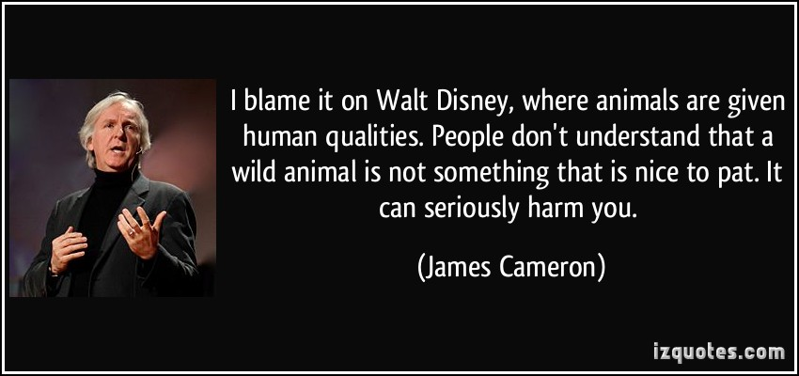

Activities:
Discuss the above quote. How do we view animals in our society? Do we respect them the way that we should?
http://www.theguardian.com/world/video/2015/may/11/black-bears-run-at-tourists-in-us-national-park-montana-video
Read John Steinbeck’s Travels with Charley
How does this Steinbeck’s experience relate to those at Yellowstone?
Focus on similarities and differences between McCandless, Ralston, Muir, Thoreau, Bryson and Steinbeck. Make a chart, answering the following questions?
- Do you think the author respects nature? Explain.
- Name a decision in each story that changed each of their lives. Did they learn from that decision?
- Do any of these people fear parts of nature? If so, should they or should they not? Explain.
- How do you think their stories might inspire people to go out in nature? To avoid it?

Assessment (based on state released writing prompt shown below in box):
Write an essay in which you discuss your favorite season. Write an explanatory essay for your teacher expressing clear details about that seasons and name an event that happened during this season. Include facts, details, and precise language as they are appropriate in your writing.

Scoring Guide:
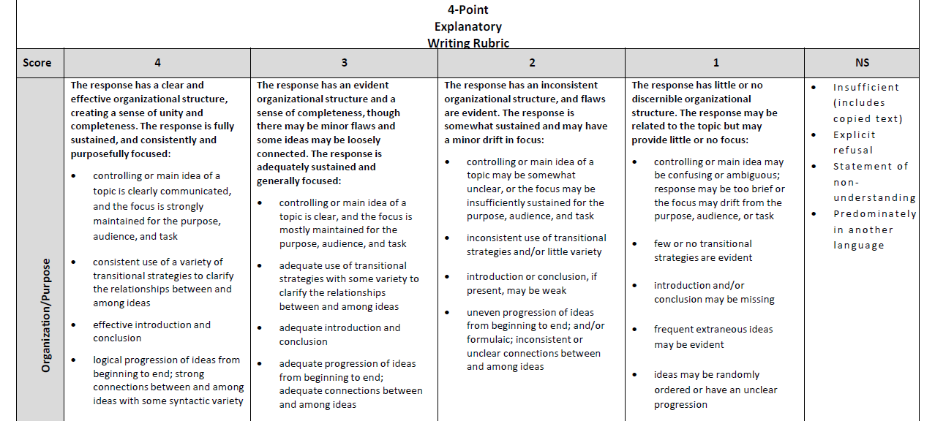

List of Materials:
It should be noted that our district only allows teachers 600 copies per month. This copy is one side only. I had roughly 150 students last year. This means each student is only allotted four copies, front and back, every 30 days. We do not have textbooks, so many, if not all these copies, are used for the reading themselves. This means I very, very rarely use a worksheet. I rely on activities where they can use their own paper.

Lesson One:
Field note examples. Prezi.

Lesson Two:
Ordeal by Cheque:
http://www.corbettharrison.com/documents/OrdealbyCheque.pdf

Dialectical Journal:
http://txla.org/sites/tla/files/groups/YART/docs/2015SPOTHigh-McCall_AcademicProgram_DialecticalJournalHandout.pdf

Guide for Into the Wild:
http://www.randomhouse.com/catalog/teachers_guides/9780385486804.pdf

Scoring guide for essay after film:
http://dese.mo.gov/sites/default/files/cur-ela-eoc-argumentative-rubric.pdf

Lesson Three:

Map of the four corners:
http://fourcornershotels.net/four-corners-map/

Lesson Four:
The National Parks: America’s Best Idea DVD set.

Skype

The “Emerson of Yosemite Passage”

Emerson, Agassiz, Gray -- these men influenced me more than any others. Yes, the most of my years were spent on the wild side of the continent, invisible, in the forests and mountains. These men were the first to find me and hail me as a brother.
First of all, and greatest of all, came Emerson. I was then living in Yosemite Valley as a convenient and grand vestibule of the Sierra from which I could make excursions into the adjacent mountains. I had not much money and was then running a mill that I had built to saw fallen timber for cottages. When he came into the Valley I heard the hotel people saying with solemn emphasis, "Emerson is here." I was excited as I had never been excited before, and my heart throbbed as if an angel direct from heaven had alighted on the Sierran rocks. But so great was my awe and reverence, I did not dare to go to him or speak to him. I hovered on the outside of the crowd of people that were pressing forward to be introduced to him and shaking hands with him. Then I heard that in three or four days he was going away, and in the course of sheer desperation I wrote him a note and carried it to his hotel telling him that E1 Capitan and Tissiack demanded him to stay longer.
The next day he inquired for the writer and was directed to the little sawmill. He came to the mill on horseback attended by Mr. Thayer[James Bradley Thayer, a member of Emerson's party, who, in 1884, published a little volume of reminiscences under the title of A Western Journey with Mr. Emerson.] and inquired for me. I stepped out and said, "I am Mr. Muir." "Then Mr. Muir must have brought his own letter," said Mr. Thayer and Emerson said, "Why did you not make yourself known last evening? I should have been very glad to have seen you." Then he dismounted and came into the mill. I had a study attached to the gable of the mill, overhanging the stream, into which I invited him, but it was not easy of access, being reached only by a series of sloping planks roughened by slats like a hen ladder; but he bravely climbed up and I showed him my collection of plants and sketches drawn from the surrounding mountains which seemed to interest him greatly, and he asked many questions, pumping unconscionably.
He came again and again, and I saw him every day while he remained in the valley, and on leaving I was invited to accompany him as far as the Mariposa Grove of Big Trees. I said, "I'll go, Mr. Emerson, if you will promise to camp with me in the Grove. I'll build a glorious campfire, and the great brown boles of the giant Sequoias will be most impressively lighted up, and the night will be glorious." At this he became enthusiastic like a boy, his sweet perennial smile became still deeper and sweeter, and he said, "Yes, yes, we will camp out, camp out"; and so next day we left Yosemite and rode twenty five miles through the Sierra forests, the noblest on the face of the earth, and he kept me talking all the time, but said little himself. The colossal silver firs, Douglas spruce, Libocedrus and sugar pine, the kings and priests of the conifers of the earth, filled him with awe and delight. When we stopped to eat luncheon he called on different members of the party to tell stories or recite poems, etc., and spoke, as he reclined on the carpet of pine needles, of his student days at Harvard. But when in the afternoon we came to the Wawona Tavern . . . .
There the memorandum ends, but the continuation is found in his volume Our National Parks at the conclusion of the chapter on "The Forests of the Yosemite":
Early in the afternoon, when we reached Clark's Station, I was surprised to see the party dismount And when I asked if we were not going up into the grove to camp they said: "No; it would never do to lie out in the night air. Mr. Emerson might take cold; and you know, Mr. Muir, that would be a dreadful thing." In vain I urged, that only in homes and hotels were colds caught, that nobody ever was known to take cold camping in these woods, that there was not a single cough or sneeze in all the Sierra. Then I pictured the big climate changing, inspiring fire I would make, praised the beauty and fragrance of Sequoia flame, told how the great trees would stand about us transfigured in purple light, while the stars looked between the great domes; ending by urging them to come on and make an immortal Emerson night of it. But the house habit was not to be overcome, nor the strange dread of pure night air, though it is only cooled day air with a little dew in it. So the carpet dust and unknowable reeks were preferred. And to think of this being a Boston choice. Sad commentary on culture and the glorious transcendentalism.
Accustomed to reach whatever place I started for, I was going up the mountain alone to camp, and wait the coming of the party next day. But since Emerson was so soon to vanish, I concluded to stop with him. He hardly spoke a word all evening, yet it was a great pleasure simply to be with him, warming in the light of his face as at a fire. In the morning we rode up the trail through a noble forest of pine and fir into the famous Mariposa Grove, and stayed an hour or two, mostly in ordinary tourist fashion,--looking at the biggest giants, measuring them with a tape line, riding through prostrate fire-bored trunks etc., though Mr. Emerson was alone occasionally, sauntering about as if under a spell. As we walked through a fine group, he quoted, "There were giants in those days," recognizing the antiquity of the race. To commemorate his visit, Mr. Galen Clark, the guardian of the grove, selected the finest of the unnamed trees and requested him to give it a name. He named it Samoset, after the New England sachem, as the best that occurred to him.
The poor bit of measured time was soon spent, and while the saddles were being adjusted I again urged Emerson to stay. "You are yourself a Sequoia," I said. "Stop and get acquainted with your big brethren." But he was past his prime, and was now a child in the hands of his affectionate but sadly civilized friends, who seemed as full of old-fashioned conformity as of bold intellectual independence. It was the afternoon of the day and the afternoon of his life, and his course was now westward down all the mountains into the sunset. The party mounted and rode away in wondrous contentment apparently, tracing the trail through ceanothus and dogwood bushes, around the bases of the big trees, up the slope of the sequoia basin, and over the divide. I followed to the edge of the grove. Emerson lingered in the rear of the train, and when he reached the top of the ridge, after all the rest of the party were over and out of sight, he turned his horse, took off his hat and waved me a last good-bye. I felt lonely, so sure had I been that Emerson of all men would be the quickest to see the mountains and sing them. Gazing awhile on the spot where he vanished, I sauntered back into the heart of the grove, made a bed of sequoia plumes and ferns by the side of the stream, gathered a store of firewood, and then walked about until sundown. The birds, robins, thrushes, warblers, etc., that had kept out of sight, came about me, now that all was quiet, and made cheer. After sundown I built a great fire, and as usual had it all to myself. And though lonesome for the first time in these forests, I quickly took heart again--the trees had not gone to Boston, nor the birds; and as I sat by the fire, Emerson was still with me in spiry, though I never again saw him in the flesh. But there remained many a forest to wander through, many a mountain and glacier to cross, before I was to see his Wachusett and Monadnock, Boston and Concord. It was seventeen years after our parting on the Wawona ridge that I stood beside his grave under a pine tree on the hill above Sleepy Hollow. He had gone to higher Sierras, and, as I fancied, was again waving his hand in friendly recognition.

Lesson Five:

Answers for finding allusions group work:

1. E.B. White wrote of this sentence: "A copy-desk man would get a double hernia trying to clean up that sentence for the management, but the sentence needs no fixing, for it perfectly captures the meaning of the writer and the quality of the ramble." - back
2. William Cowper (1731-1800) English poet, hymnist, The Solitude of Alexander Selkirk (italics by Thoreau, who was a surveyor) - back
3. in Greek mythology Atlas supported the heavens on his shoulders - back
4. Marcus Porcius Cato (234-149 B.C.) Roman agricultural author - back
5. De Re Rustica (Agriculture), by Roman authors Marcus Porcius Cato (234-149 BC) and Marcus Terentius Varro (116 BC-27 BC) - back
6. publications of Thoreau's time, such as the Boston Cultivator or the New England Cultivator - back
7. in Greek mythology, home of the gods - back
8. 5th century Hindu epic poem - back
9. another name for the Hindu god Krishna - back
10. Cassiopeia's Chair, Pleiades, and Hyades are constellations, Aldebaran and Altair are stars - back
11. anonymous, published 1610 - back
12. in Roman mythology, the goddess of dawn - back
13. another name for Confucius - back
14. Iliad and Odyssey, attributed to Homer, 8th cent. B.C. Greek epic poet - back
15. Brahmin religious books - back
16. statue in ancient Egypt said to produce music at dawn - back
17. Westminster Catechism - back
18. group of European states, 1815-1866 - back
19. like the Spartans of ancient Greece, disciplined, austere - back
20. wooden railroad ties that support the rails - back
21. chorea, a nervous disorder characterized by involuntary movements - back
22. river in Arkansas and Louisiana - back
23. relating to Spanish & Portuguese politics, 1830's & 1840's - back
24. character in a book by Confucius - back
25. Brahma, Hindu god of creation - back
26. Roman name for Odysseus, character in Homer's Iliad and Odyssey - back
27. a point of support - back
28. gauge used to measure the rise of the Nile River in Egypt - back
29. also called a scimiter, a saber with a curved blade, used in the Middle East - back

Excerpt from Walden
[7] The present was my next experiment of this kind, which I purpose to describe more at length, for convenience putting the experience of two years into one. As I have said, I do not propose to write an ode to dejection, but to brag as lustily as chanticleer in the morning, standing on his roost, if only to wake my neighbors up.
[8] When first I took up my abode in the woods, that is, began to spend my nights as well as days there, which, by accident, was on Independence Day, or the Fourth of July, 1845, my house was not finished for winter, but was merely a defence against the rain, without plastering or chimney, the walls being of rough, weather-stained boards, with wide chinks, which made it cool at night. The upright white hewn studs and freshly planed door and window casings gave it a clean and airy look, especially in the morning, when its timbers were saturated with dew, so that I fancied that by noon some sweet gum would exude from them. To my imagination it retained throughout the day more or less of this auroral character, reminding me of a certain house on a mountain which I had visited a year before. This was an airy and unplastered cabin, fit to entertain a travelling god, and where a goddess might trail her garments. The winds which passed over my dwelling were such as sweep over the ridges of mountains, bearing the broken strains, or celestial parts only, of terrestrial music. The morning wind forever blows, the poem of creation is uninterrupted; but few are the ears that hear it. Olympus (7) is but the outside of the earth everywhere.
[9] The only house I had been the owner of before, if I except a boat, was a tent, which I used occasionally when making excursions in the summer, and this is still rolled up in my garret; but the boat, after passing from hand to hand, has gone down the stream of time. With this more substantial shelter about me, I had made some progress toward settling in the world. This frame, so slightly clad, was a sort of crystallization around me, and reacted on the builder. It was suggestive somewhat as a picture in outlines. I did not need to go outdoors to take the air, for the atmosphere within had lost none of its freshness. It was not so much within doors as behind a door where I sat, even in the rainiest weather. The Harivansa (8) says, "An abode without birds is like a meat without seasoning." Such was not my abode, for I found myself suddenly neighbor to the birds; not by having imprisoned one, but having caged myself near them. I was not only nearer to some of those which commonly frequent the garden and the orchard, but to those smaller and more thrilling songsters of the forest which never, or rarely, serenade a villager — the wood thrush, the veery, the scarlet tanager, the field sparrow, the whip-poor-will, and many others.
[10] I was seated by the shore of a small pond, about a mile and a half south of the village of Concord and somewhat higher than it, in the midst of an extensive wood between that town and Lincoln, and about two miles south of that our only field known to fame, Concord Battle Ground; but I was so low in the woods that the opposite shore, half a mile off, like the rest, covered with wood, was my most distant horizon. For the first week, whenever I looked out on the pond it impressed me like a tarn high up on the side of a mountain, its bottom far above the surface of other lakes, and, as the sun arose, I saw it throwing off its nightly clothing of mist, and here and there, by degrees, its soft ripples or its smooth reflecting surface was revealed, while the mists, like ghosts, were stealthily withdrawing in every direction into the woods, as at the breaking up of some nocturnal conventicle. The very dew seemed to hang upon the trees later into the day than usual, as on the sides of mountains.
[11] This small lake was of most value as a neighbor in the intervals of a gentle rain-storm in August, when, both air and water being perfectly still, but the sky overcast, mid-afternoon had all the serenity of evening, and the wood thrush sang around, and was heard from shore to shore. A lake like this is never smoother than at such a time; and the clear portion of the air above it being, shallow and darkened by clouds, the water, full of light and reflections, becomes a lower heaven itself so much the more important. From a hill-top near by, where the wood had been recently cut off, there was a pleasing vista southward across the pond, through a wide indentation in the hills which form the shore there, where their opposite sides sloping toward each other suggested a stream flowing out in that direction through a wooded valley, but stream there was none. That way I looked between and over the near green hills to some distant and higher ones in the horizon, tinged with blue. Indeed, by standing on tiptoe I could catch a glimpse of some of the peaks of the still bluer and more distant mountain ranges in the northwest, those true-blue coins from heaven's own mint, and also of some portion of the village. But in other directions, even from this point, I could not see over or beyond the woods which surrounded me. It is well to have some water in your neighborhood, to give buoyancy to and float the earth. One value even of the smallest well is, that when you look into it you see that earth is not continent but insular. This is as important as that it keeps butter cool. When I looked across the pond from this peak toward the Sudbury meadows, which in time of flood I distinguished elevated perhaps by a mirage in their seething valley, like a coin in a basin, all the earth beyond the pond appeared like a thin crust insulated and floated even by this small sheet of interverting water, and I was reminded that this on which I dwelt was but dry land.
[12] Though the view from my door was still more contracted, I did not feel crowded or confined in the least. There was pasture enough for my imagination. The low shrub oak plateau to which the opposite shore arose stretched away toward the prairies of the West and the steppes of Tartary, affording ample room for all the roving families of men. "There are none happy in the world but beings who enjoy freely a vast horizon" — said Damodara,(9) when his herds required new and larger pastures.
[13] Both place and time were changed, and I dwelt nearer to those parts of the universe and to those eras in history which had most attracted me. Where I lived was as far off as many a region viewed nightly by astronomers. We are wont to imagine rare and delectable places in some remote and more celestial corner of the system, behind the constellation of Cassiopeia's Chair, far from noise and disturbance. I discovered that my house actually had its site in such a withdrawn, but forever new and unprofaned, part of the universe. If it were worth the while to settle in those parts near to the Pleiades or the Hyades, to Aldebaran or Altair,(10) then I was really there, or at an equal remoteness from the life which I had left behind, dwindled and twinkling with as fine a ray to my nearest neighbor, and to be seen only in moonless nights by him. Such was that part of creation where I had squatted, —
"There was a shepherd that did live,
And held his thoughts as high
As were the mounts whereon his flocks
Did hourly feed him by."(11)
What should we think of the shepherd's life if his flocks always wandered to higher pastures than his thoughts?
[14] Every morning was a cheerful invitation to make my life of equal simplicity, and I may say innocence, with Nature herself. I have been as sincere a worshipper of Aurora (12) as the Greeks. I got up early and bathed in the pond; that was a religious exercise, and one of the best things which I did. They say that characters were engraven on the bathing tub of King Tching Thang (13) to this effect: "Renew thyself completely each day; do it again, and again, and forever again." I can understand that. Morning brings back the heroic ages. I was as much affected by the faint hum of a mosquito making its invisible and unimaginable tour through my apartment at earliest dawn, when I was sitting with door and windows open, as I could be by any trumpet that ever sang of fame. It was Homer's requiem; itself an Iliad and Odyssey (14) in the air, singing its own wrath and wanderings. There was something cosmical about it; a standing advertisement, till forbidden, of the everlasting vigor and fertility of the world. The morning, which is the most memorable season of the day, is the awakening hour. Then there is least somnolence in us; and for an hour, at least, some part of us awakes which slumbers all the rest of the day and night. Little is to be expected of that day, if it can be called a day, to which we are not awakened by our Genius, but by the mechanical nudgings of some servitor, are not awakened by our own newly acquired force and aspirations from within, accompanied by the undulations of celestial music, instead of factory bells, and a fragrance filling the air — to a higher life than we fell asleep from; and thus the darkness bear its fruit, and prove itself to be good, no less than the light. That man who does not believe that each day contains an earlier, more sacred, and auroral hour than he has yet profaned, has despaired of life, and is pursuing a descending and darkening way. After a partial cessation of his sensuous life, the soul of man, or its organs rather, are reinvigorated each day, and his Genius tries again what noble life it can make. All memorable events, I should say, transpire in morning time and in a morning atmosphere. The Vedas (15) say, "All intelligences awake with the morning." Poetry and art, and the fairest and most memorable of the actions of men, date from such an hour. All poets and heroes, like Memnon,(16) are the children of Aurora, and emit their music at sunrise. To him whose elastic and vigorous thought keeps pace with the sun, the day is a perpetual morning. It matters not what the clocks say or the attitudes and labors of men. Morning is when I am awake and there is a dawn in me. Moral reform is the effort to throw off sleep. Why is it that men give so poor an account of their day if they have not been slumbering? They are not such poor calculators. If they had not been overcome with drowsiness, they would have performed something. The millions are awake enough for physical labor; but only one in a million is awake enough for effective intellectual exertion, only one in a hundred millions to a poetic or divine life. To be awake is to be alive. I have never yet met a man who was quite awake. How could I have looked him in the face?
[15] We must learn to reawaken and keep ourselves awake, not by mechanical aids, but by an infinite expectation of the dawn, which does not forsake us in our soundest sleep. I know of no more encouraging fact than the unquestionable ability of man to elevate his life by a conscious endeavor. It is something to be able to paint a particular picture, or to carve a statue, and so to make a few objects beautiful; but it is far more glorious to carve and paint the very atmosphere and medium through which we look, which morally we can do. To affect the quality of the day, that is the highest of arts. Every man is tasked to make his life, even in its details, worthy of the contemplation of his most elevated and critical hour. If we refused, or rather used up, such paltry information as we get, the oracles would distinctly inform us how this might be done.

[16] I went to the woods because I wished to live deliberately, to front only the essential facts of life, and see if I could not learn what it had to teach, and not, when I came to die, discover that I had not lived. I did not wish to live what was not life, living is so dear; nor did I wish to practise resignation, unless it was quite necessary. I wanted to live deep and suck out all the marrow of life, to live so sturdily and Spartan-like as to put to rout all that was not life, to cut a broad swath and shave close, to drive life into a corner, and reduce it to its lowest terms, and, if it proved to be mean, why then to get the whole and genuine meanness of it, and publish its meanness to the world; or if it were sublime, to know it by experience, and be able to give a true account of it in my next excursion. For most men, it appears to me, are in a strange uncertainty about it, whether it is of the devil or of God, and have somewhat hastily concluded that it is the chief end of man here to "glorify God and enjoy him forever."(17)
[17] Still we live meanly, like ants; though the fable tells us that we were long ago changed into men; like pygmies we fight with cranes; it is error upon error, and clout upon clout, and our best virtue has for its occasion a superfluous and evitable wretchedness. Our life is frittered away by detail. An honest man has hardly need to count more than his ten fingers, or in extreme cases he may add his ten toes, and lump the rest. Simplicity, simplicity, simplicity! I say, let your affairs be as two or three, and not a hundred or a thousand; instead of a million count half a dozen, and keep your accounts on your thumb-nail. In the midst of this chopping sea of civilized life, such are the clouds and storms and quicksands and thousand-and-one items to be allowed for, that a man has to live, if he would not founder and go to the bottom and not make his port at all, by dead reckoning, and he must be a great calculator indeed who succeeds. Simplify, simplify. Instead of three meals a day, if it be necessary eat but one; instead of a hundred dishes, five; and reduce other things in proportion. Our life is like a German Confederacy,(18) made up of petty states, with its boundary forever fluctuating, so that even a German cannot tell you how it is bounded at any moment. The nation itself, with all its so-called internal improvements, which, by the way are all external and superficial, is just such an unwieldy and overgrown establishment, cluttered with furniture and tripped up by its own traps, ruined by luxury and heedless expense, by want of calculation and a worthy aim, as the million households in the land; and the only cure for it, as for them, is in a rigid economy, a stern and more than Spartan (19) simplicity of life and elevation of purpose. It lives too fast. Men think that it is essential that the Nation have commerce, and export ice, and talk through a telegraph, and ride thirty miles an hour, without a doubt, whether they do or not; but whether we should live like baboons or like men, is a little uncertain.If we do not get out sleepers,(20) and forge rails, and devote days and nights to the work, but go to tinkering upon our lives to improve them, who will build railroads? And if railroads are not built, how shall we get to heaven in season? But if we stay at home and mind our business, who will want railroads? We do not ride on the railroad; it rides upon us. Did you ever think what those sleepers are that underlie the railroad? Each one is a man, an Irishman, or a Yankee man. The rails are laid on them, and they are covered with sand, and the cars run smoothly over them. They are sound sleepers, I assure you. And every few years a new lot is laid down and run over; so that, if some have the pleasure of riding on a rail, others have the misfortune to be ridden upon. And when they run over a man that is walking in his sleep, a supernumerary sleeper in the wrong position, and wake him up, they suddenly stop the cars, and make a hue and cry about it, as if this were an exception. I am glad to know that it takes a gang of men for every five miles to keep the sleepers down and level in their beds as it is, for this is a sign that they may sometime get up again.
[18] Why should we live with such hurry and waste of life? We are determined to be starved before we are hungry. Men say that a stitch in time saves nine, and so they take a thousand stitches today to save nine tomorrow. As for work, we haven't any of any consequence. We have the Saint Vitus' dance,(21) and cannot possibly keep our heads still. If I should only give a few pulls at the parish bell-rope, as for a fire, that is, without setting the bell, there is hardly a man on his farm in the outskirts of Concord, notwithstanding that press of engagements which was his excuse so many times this morning, nor a boy, nor a woman, I might almost say, but would forsake all and follow that sound, not mainly to save property from the flames, but, if we will confess the truth, much more to see it burn, since burn it must, and we, be it known, did not set it on fire — or to see it put out, and have a hand in it, if that is done as handsomely; yes, even if it were the parish church itself. Hardly a man takes a half-hour's nap after dinner, but when he wakes he holds up his head and asks, "What's the news?" as if the rest of mankind had stood his sentinels. Some give directions to be waked every half-hour, doubtless for no other purpose; and then, to pay for it, they tell what they have dreamed. After a night's sleep the news is as indispensable as the breakfast. "Pray tell me anything new that has happened to a man anywhere on this globe" — and he reads it over his coffee and rolls, that a man has had his eyes gouged out this morning on the Wachito River;(22) never dreaming the while that he lives in the dark unfathomed mammoth cave of this world, and has but the rudiment of an eye himself.
[19] For my part, I could easily do without the post-office. I think that there are very few important communications made through it. To speak critically, I never received more than one or two letters in my life — I wrote this some years ago — that were worth the postage. The penny-post is, commonly, an institution through which you seriously offer a man that penny for his thoughts which is so often safely offered in jest. And I am sure that I never read any memorable news in a newspaper. If we read of one man robbed, or murdered, or killed by accident, or one house burned, or one vessel wrecked, or one steamboat blown up, or one cow run over on the Western Railroad, or one mad dog killed, or one lot of grasshoppers in the winter — we never need read of another. One is enough. If you are acquainted with the principle, what do you care for a myriad instances and applications? To a philosopher all news, as it is called, is gossip, and they who edit and read it are old women over their tea. Yet not a few are greedy after this gossip. There was such a rush, as I hear, the other day at one of the offices to learn the foreign news by the last arrival, that several large squares of plate glass belonging to the establishment were broken by the pressure — news which I seriously think a ready wit might write a twelve-month, or twelve years, beforehand with sufficient accuracy. As for Spain, for instance, if you know how to throw in Don Carlos and the Infanta, and Don Pedro and Seville and Granada,(23) from time to time in the right proportions — they may have changed the names a little since I saw the papers — and serve up a bull-fight when other entertainments fail, it will be true to the letter, and give us as good an idea of the exact state or ruin of things in Spain as the most succinct and lucid reports under this head in the newspapers: and as for England, almost the last significant scrap of news from that quarter was the revolution of 1649; and if you have learned the history of her crops for an average year, you never need attend to that thing again, unless your speculations are of a merely pecuniary character. If one may judge who rarely looks into the newspapers, nothing new does ever happen in foreign parts, a French revolution not excepted.
[20] What news! how much more important to know what that is which was never old! "Kieou-pe-yu (24) (great dignitary of the state of Wei) sent a man to Khoung-tseu to know his news. Khoung-tseu caused the messenger to be seated near him, and questioned him in these terms: What is your master doing? The messenger answered with respect: My master desires to diminish the number of his faults, but he cannot accomplish it.. The messenger being gone, the philosopher remarked: What a worthy messenger! What a worthy messenger!" The preacher, instead of vexing the ears of drowsy farmers on their day of rest at the end of the week — for Sunday is the fit conclusion of an ill-spent week, and not the fresh and brave beginning of a new one — with this one other draggle-tail of a sermon, should shout with thundering voice, "Pause! Avast! Why so seeming fast, but deadly slow?"
[21] Shams and delusions are esteemed for soundest truths, while reality is fabulous. If men would steadily observe realities only, and not allow themselves to be deluded, life, to compare it with such things as we know, would be like a fairy tale and the Arabian Nights' Entertainments. If we respected only what is inevitable and has a right to be, music and poetry would resound along the streets. When we are unhurried and wise, we perceive that only great and worthy things have any permanent and absolute existence, that petty fears and petty pleasures are but the shadow of the reality. This is always exhilarating and sublime. By closing the eyes and slumbering, and consenting to be deceived by shows, men establish and confirm their daily life of routine and habit everywhere, which still is built on purely illusory foundations. Children, who play life, discern its true law and relations more clearly than men, who fail to live it worthily, but who think that they are wiser by experience, that is, by failure. I have read in a Hindoo book, that "there was a king's son, who, being expelled in infancy from his native city, was brought up by a forester, and, growing up to maturity in that state, imagined himself to belong to the barbarous race with which he lived. One of his father's ministers having discovered him, revealed to him what he was, and the misconception of his character was removed, and he knew himself to be a prince. So soul," continues the Hindoo philosopher, "from the circumstances in which it is placed, mistakes its own character, until the truth is revealed to it by some holy teacher, and then it knows itself to be Brahme."(25) I perceive that we inhabitants of New England live this mean life that we do because our vision does not penetrate the surface of things. We think that that is which appears to be. If a man should walk through this town and see only the reality, where, think you, would the "Mill-dam" go to? If he should give us an account of the realities he beheld there, we should not recognize the place in his description. Look at a meeting-house, or a court-house, or a jail, or a shop, or a dwelling-house, and say what that thing really is before a true gaze, and they would all go to pieces in your account of them. Men esteem truth remote, in the outskirts of the system, behind the farthest star, before Adam and after the last man. In eternity there is indeed something true and sublime. But all these times and places and occasions are now and here. God himself culminates in the present moment, and will never be more divine in the lapse of all the ages. And we are enabled to apprehend at all what is sublime and noble only by the perpetual instilling and drenching of the reality that surrounds us. The universe constantly and obediently answers to our conceptions; whether we travel fast or slow, the track is laid for us. Let us spend our lives in conceiving then. The poet or the artist never yet had so fair and noble a design but some of his posterity at least could accomplish it.
[22] Let us spend one day as deliberately as Nature, and not be thrown off the track by every nutshell and mosquito's wing that falls on the rails. Let us rise early and fast, or break fast, gently and without perturbation; let company come and let company go, let the bells ring and the children cry — determined to make a day of it. Why should we knock under and go with the stream? Let us not be upset and overwhelmed in that terrible rapid and whirlpool called a dinner, situated in the meridian shallows. Weather this danger and you are safe, for the rest of the way is down hill. With unrelaxed nerves, with morning vigor, sail by it, looking another way, tied to the mast like Ulysses.(26) If the engine whistles, let it whistle till it is hoarse for its pains. If the bell rings, why should we run? We will consider what kind of music they are like. Let us settle ourselves, and work and wedge our feet downward through the mud and slush of opinion, and prejudice, and tradition, and delusion, and appearance, that alluvion which covers the globe, through Paris and London, through New York and Boston and Concord, through Church and State, through poetry and philosophy and religion, till we come to a hard bottom and rocks in place, which we can call reality, and say, This is, and no mistake; and then begin, having a point d'appui,(27) below freshet and frost and fire, a place where you might found a wall or a state, or set a lamp-post safely, or perhaps a gauge, not a Nilometer,(28) but a Realometer, that future ages might know how deep a freshet of shams and appearances had gathered from time to time. If you stand right fronting and face to face to a fact, you will see the sun glimmer on both its surfaces, as if it were a cimeter,(29) and feel its sweet edge dividing you through the heart and marrow, and so you will happily conclude your mortal career. Be it life or death, we crave only reality. If we are really dying, let us hear the rattle in our throats and feel cold in the extremities; if we are alive, let us go about our business.
[23] Time is but the stream I go a-fishing in. I drink at it; but while I drink I see the sandy bottom and detect how shallow it is. Its thin current slides away, but eternity remains. I would drink deeper; fish in the sky, whose bottom is pebbly with stars. I cannot count one. I know not the first letter of the alphabet. I have always been regretting that I was not as wise as the day I was born. The intellect is a cleaver; it discerns and rifts its way into the secret of things. I do not wish to be any more busy with my hands than is necessary. My head is hands and feet. I feel all my best faculties concentrated in it. My instinct tells me that my head is an organ for burrowing, as some creatures use their snout and fore paws, and with it I would mine and burrow my way through these hills. I think that the richest vein is somewhere hereabouts; so by the divining-rod and thin rising vapors I judge; and here I will begin to mine.

http://www.kdl.org/kdl/pdf/BookClubBag/WalkWoods.pdf

Scoring guide for essay http://dese.mo.gov/sites/default/files/cur-ela-eoc-narrative-rubric.pdf

Grading System:
Gateway STEM has a 50/50 grading system. Assignments are worth 50% of their grades, while tests are also worth 50%. Papers fall into the test/assessment category as well.

Assignments (50%) are broken down into three groups. “Do Nows” or “Bell Ringers” are worth 10% of this grade. Homework is worth 20% and classwork that turns into homework is 30%.

State Pretest Prompt: http://dese.mo.gov/sites/default/files/EOC_English_2_Pretest_Session_2_1-12-15.pdf

State Scoring Guides:
http://dese.mo.gov/sites/default/files/cur-ela-eoc-explanatory-rubric.pdf

State Standards http://www.missourilearningstandards.com/files/CCSSI_ELA-Standards3.pdf

Other:

Works Cited:

127 Hours. Fox Searchlight Films, 2010. DVD.

Bryson, Bill. A Walk in the Woods: Rediscovering America on the Appalachian Trail. New York: Broadway, 1998. Print.

"Into the Wild Common Core ELA Teacher's Guide." Random House Teacher Guides. Random House. Web. 4 Aug. 2015.

Krakauer, Jon. Into the Wild. New York: Anchor, 1997. Print.

Muir, John, and Edwin Way Teale. The Wilderness World of John Muir. Boston: Houghton Mifflin, 1954. Print.

Ralston, Aron. Between a Rock and a Hard Place. New York: Atria, 2004. Print.

RedClay, Mary, and James Frieden. "Lesson Plans Based on Movies & Film Clips!” Into the Wild. Teach with Movies. Web. 4 Aug. 2015.

Steinbeck, John. Travels with Charley: In Search of America. New York: Viking, 1962. Print.

The National Parks: America's Best Idea. PBS Distribution, 2009. Film

Thoreau, Henry David, and Owen Paul Thomas. Walden and Civil Disobedience: Authoritative Texts, Background, Reviews, and Essays in Criticism. New York: W.W. Norton, 1966. Print.

